**California Needs the Existing Biomass Industry**

**Introduction**

Biomass power plants combust wood waste to produce electricity – material that would otherwise create adverse environmental impacts. Among the wood waste used are:

* Agricultural waste like orchard removals, pruning, rice hulls and fruit pits.
* Urban wood waste like construction wood scraps, broken pallets and tree trimmings.
* Forest waste like small trees and undergrowth cleared from forests as part of fire suppression.

Unlike most renewable power, biomass plants are baseload renewable and are not dependent upon Mother Nature to produce power.

Aside from renewable energy, biomass plants provide positive environmental and economic impacts that other sources of renewable energy cannot.

**About the Industry**

There are 25 biomass electric generating plants, distributed across 20 counties. The biomass plants combined produce more than 565 megawatts of baseload renewable energy. That is enough to power more than 420,000 homes, nearly all of Sacramento County’s residences.

**Environmental Benefits**

California’s current plants use more than 8 million tons of wood waste as fuel annually that would otherwise clog the landfills, left to decay and serve as a fire hazard in the forest, or open burned. About 3.7 million tons of wood waste is urban wood waste diverted from landfills thereby helping local governments meet landfill diversion mandates. Biomass plants promote healthier forests by reducing the amount of overgrowth materials in the forests as well as open burns by the agricultural community. In fact, there is a direct correlation to the increase in burn permits and a recent closure of a biomass power plant.

**Economic Benefits**

California’s biomass plants employ roughly 700 people directly and support between 1,000 and 1,500 additional dedicated indirect jobs used in gathering fuel supply. Many of these jobs are in rural areas that often face higher unemployment. In fact, in many communities, the biomass plants are one of the largest private employers.

According to a recent study, an average biomass plant spends more than $3 million in benefits and salaries. The average plant also has annual expenditures in excess of $20 million and contributes more than $2 million in state and local taxes.

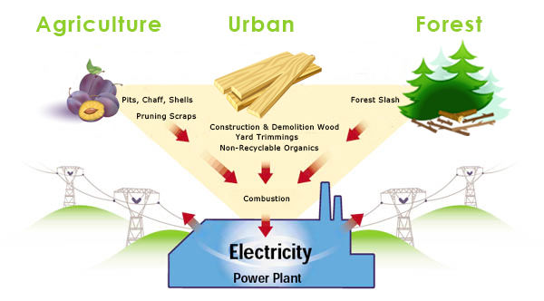**Energy Benefits**

Biomass is a reliable, renewable, baseload electric power source that provides a steady flow of power regardless of external conditions. The biomass plants provide another valuable tool in ensuring that the state meets its current renewable portfolio standard of 33% by 2020. In fact, biomass plants provide more than 16 percent of all of PG&E renewable portfolio.

**Industry Is In Jeopardy**

Despite the benefits of biomass power, the industry is in jeopardy. In the past year, five plants have closed due to antiquated contracts that do not cover all of the plants’ costs. Half of the remaining plants are facing expiring contracts. Without new contracts and revenue streams that reward biomass plants for all of their attributes, half the industry will cease to exist.

|  |  |  |  |
| --- | --- | --- | --- |
| Plant Name | County | Net MW | Employees |
| Dinuba | Tulare | 11.5 | 10 |
| Delano | Kern | 50 | 50 |
| DG Fairhaven | Humboldt | 17.5 | 22 |
| Collins Pine | Plumas | 6 | 18 |
| Honey Lake Power | Lassen | 30 | 25 |
| Rio Bravo Fresno | Fresno | 25 | 29 |
| Chinese Station | Tuolumne | 20 | 24 |
| Burney Forest Power | Shasta | 31 | 24 |
| Rio Bravo Rocklin | Placer | 25 | 29 |
| Wheelabrator Shasta | Shasta | 50 | 50 |
| Wadham Energy | Colusa | 25 | 23 |
| Woodland Biomass Power | Yolo | 25 | 35 |

That means more than 300 megawatts of baseload renewable energy will no longer be available. Millions of tons of wood waste will once again be open burned or sent to landfills. Most importantly, more than 1,000 people will be out of work. In many instances, the biomass plants at risk are some of the largest private employers in their community.

**Solution**

California needs biomass power to meet its various environmental, health and economic goals. Therefore, California needs to provide support for this valuable industry by appropriating greenhouse gas reduction funds (GGRF) to pay for the environmental and economic benefit it derives from biomass power generation. Assembly Bill 590 (Dahle) does just that.

The amount of the state benefit roughly corresponds to the fuel cost contribution of power generation from biomass.

GGRF funds are an appropriate use of funds because using waste and residue forms of biomass – agricultural residues, urban and forest wood waste – in the production of electricity reduces GHG emissions. In the absence of this energy conversation, the bulk of these materials would otherwise be open burned, buried in landfills, or allowed to remain in the forest as overgrowth material that diminishes forest health, and poses increased risks of devastating wild fires and insect and disease outbreaks.

**Action**

* Write Assembly Member Brian Dahle telling him you support AB 590.
* Write Governor Brown urging him to support AB 590 in his budget proposal.